Running Head: ONGOING JOURNEY

An Ongoing Journey
Mason Bear
AP Language and Composition
Valley High School

Abstract
CrossFit is a fitness program with beginnings in California that has spread East at a rapid rate. The gym consists solely of group led workouts containing, “constantly varied functional movements performed at high intensity.” While the gym seems normal, the participants that consistently flock to CrossFit are far from average. Those that enter the world of CrossFit find themselves in an addicting world of physical self-improvement. CrossFitters often change their habits, diets, jobs, and even living location to train. The purpose of my study is to answer the question why is CrossFit so addicting? In order to obtain data I will be observing CrossFit515, a local CrossFit gym in Des Moines, as well as participating in the workouts.

Table of Contents
Abstract 2
Table of Contents 3
Never-Never Land 4
Bobby Noyce 9
Hell’en 17
Rhabdo the Clown, Pukie, and The CrossFit Family 23
Fit For Life 29
References 33
Appendix A 34
Appendix B 35
Appendix C 36

Never-Never Land
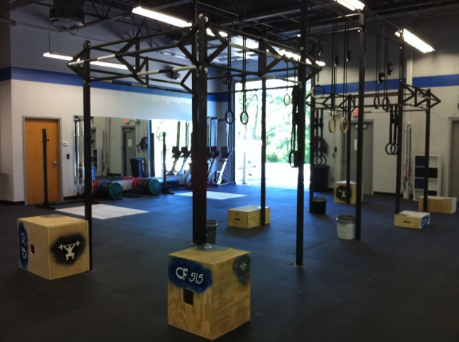

Sitting was not commonplace here; I assume I was one of the first using that plain, black bench. The seat cushion in rigidly mint condition, I felt as though it’s only visitors before me had been shoes as they were tied. My back met a looming light blue wall that rose high into the air, and my feet rested on a rubbery floor that had felt the pain of crushing weights dropped upon it. While my surroundings were foreign, my gaze remained fixated on an intricate pull-up bar system in the center of the gym. Metal bars crisscrossed, fusing themselves together to form perfect, complementary angles, as well as rings dangling in midair from the ceiling at varying heights and locations, to complete fitness artwork, but those that performed on this contraption sported calloused hands, and sweating brows rather than berets and paintbrushes.
With my attention still on the network of pull-up bars a digital clock flashes a countdown from ten in the corner of my eye. I hear the last of three high-pitched beeps and the clock begins to count upward in seconds, then the gym becomes alive. As rock music is pumped through the speakers five people run out the back door, while two boys and a girl remain in the gym furiously twirling jump ropes without missing a step. As the runners return one-by-one they take their place hurling Olympic barbells over their head while simultaneously dropping into a squat position, only to stand up straight with the weight overhead. After fifteen repetitions gravity is defied as handstand push-ups are performed against the wall; the workout is only a third of the way done. As the song comes to an end and silence falls for mere seconds’ the sounds of grunting, clanking of weights, and explosive footsteps fill the gym. The void is soon filled with the heavy metal of Metallica’s Enter Sandman, and the speaker’s blare, “TAKE MY HAND, WE’RE OFF TO NEVER, NEVER LAND!” (Personal Field Notes, 3/2/11). Sure enough I had entered the never, never land of CrossFit515.
Greg Glassman, a former gymnast, and his ex-wife Lauren Glassman are the inventors of the CrossFit ideology. In 1995 they opened the first CrossFit gym in Santa Cruz, California. The widespread definition of CrossFit is, “constantly varied functional movements performed at high intensity”. The workouts they constructed combined weightlifting, sprinting, and gymnastics, demanding proficiency in each of the ten fitness domains as follows: stamina, strength, cardiovascular/respiratory endurance, flexibility, power, speed, agility, balance, coordination, and accuracy. Their Santa Cruz gym focused on a single WOD (Workout of the Day, pronounced [wod]) often combining a mixture of running, rowing, jump roping, climbing rope, Olympic lifts, kettlebells, bodyweight exercises, and powerlifting (Wikipedia, April, 17th 2011). To top it off each workout was an individual race against the clock, and shaving seconds off a workout became an addiction. As their unique fitness program gained popularity the Glassman’s were persuaded by Ben Elizer, a CrossFit client and Silicon Valley software developer, to let his software firm launch the first-ever CrossFit website. While Silicon Valley’s finances dried up before the site was completed the Glassman’s took a ‘do it yourself’ approach. On Element CrossFit, a CrossFit blogging site, Greg Glassman writes, “On February 10th, 2001, CrossFit.com went live with a single ugly page featuring our first workout on a blue background and white font that we only months later learned printed as a blank page.” Despite that single ugly page five years later, with no money spent on advertising, CrossFit.com had 75,000 visitors daily all logging on to follow Greg Glassman’s WOD (Glassman, 2005).
Today CrossFit’s success is measured not only in its worldwide web contributions, but also in the explosion of affiliate gyms around the nation. Growing from merely eighteen gyms in 2005 to approximately 2,500 today one cannot argue that CrossFit has spread like wildfire. Although all the gyms brand themselves with the CrossFit name they remain only a loose connection under an affiliate system. Each gym pays in order to hold workout sessions and use the CrossFit name, but being an affiliate gives each branch a little more freedom in deciding how they will teach the methodology of CrossFit (Bobby Noyce, Personal Communication, March 9, 2011). In the article How to Succeed as a CrossFit Affiliate Jeremy Thiel writes,
Your affiliate is your business. It is not a cookie-cutter replica of someone else’s gym. No one is telling you how to operate, how to program and how to look. That’s both a huge opportunity and a huge burden. Your success is up to you. (Thiel, January 1st, 2010).
While the freedom exists the majority of gyms around the nation log onto CrossFit.com daily to model their workouts after Glassman’s WOD post; the loyalty of each affiliate suggests that Greg Glassman must be doing something magical.
Or maybe it is something he is not doing. At CrossFit they do not sell fat burners, or magic weight loss pills, they do not measure fitness in weight to height ratios, and they could not care less about who has the biggest arms or most defined six pack. Instead, they focus simply on their WOD times, the ongoing competition that exists in the gym, and taking care of their body. CrossFit appears to be one of the only groups left in the fitness community that holds fitness as their highest priority.
CrossFit515 is a fitness-lover’s dream. Co-owned by Bobby Noyce and his sister Jaime - both happen to be Valley graduates - the gym is an affiliate Greg Glassman would be proud of. While furnishings do not seem to be a high priority in the CrossFit world - many gyms are simply garages and warehouses - CrossFit515 is both appealing to the eye and more importantly, practical. The floor is a rubbery surface that allows for weights to be dropped upon it, the gym is open and spacious to allow stretching, jump roping, encouragement from others, and mirrors are placed strategically on the wall for members to monitor their form. The WOD is plastered on the wall in bright colors, only to be painted over in white to make room for the next day’s task. If Greg Glassman is a magician then the owners of CrossFit 515 are the workers that set the stage for him.
But as I sat on that plain, black bench magic is not the word I would use to describe what I witnessed. Thrilling, agonizing, brutal, excruciating, fit much better. From that moment on I knew that CrossFit was not for the faint of heart. I wanted in. When I started to regularly observe workouts at the gym I struggled to understand the addicting nature that drove members to show up to CrossFit515 every day, mainly because I had yet to experience a workout. I wanted to know what it was to be a CrossFitter, to put all your energy into a ten-minute workout, but gear the rest of your day towards those ten minutes. I wanted to know why and how a few short workouts could change ones idea of fitness, how they could determine one’s diet, job, and home.
When I would walk into the gym of CrossFit515 my eyes always drifted to the network of pull-up bars first. A hulking iron structure calling CrossFitters to play. Staring at the network of pull-up bars it was easy to become lost within it, where it began and ended, whether you were facing into it or out. The endlessness of it struck a similar cord as to the path of a CrossFitter. The pull-up network was centered in the middle of the gym; CrossFit is the center of the participant’s life. The pull-up network was immovable; to those that love it CrossFit is more permanent than any other aspect of their life. The pull-up bar is never-ending, just as the path of a CrossFitter is never over.

Bobby Noyce
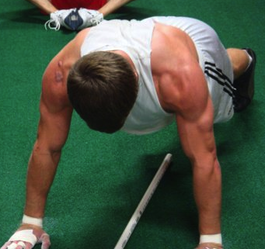

Every culture has their leader, but they are often disguised under an alias. Chief, owner, alpha-male, captain, principal, coach; all meet the same characteristics. The individual whose very mood hinges on the successes and failures of their culture. The individual that naturally puts their culture before themselves, and does not think twice about it. The individual that represents their culture in every aspect of life, and loves every minute of it. For CrossFit515 that individual is Bobby Noyce.
Bobby Noyce grew up in Des Moines attending Valley High School where he played hockey on the Des Moines Capitals for two years, as well as starting quarterback for Valley football. While he did not boast about his achievements on the field, there was no need to. Growing up in West Des Moines where most everyone attends Friday night lights Bobby Noyce was a household name. After graduation he attended Augustana College in Sioux Falls, North Dakota and was red-shirted in football, but after a year of unhappiness with the program transferred to Northwest Missouri State. After three semesters in Missouri Noyce could not find exactly what he was looking for in the business program and moved back to Des Moines to attend Drake, where he is now finishing his last semester of undergraduate work, as well as growing the CrossFit 515 gym (Bobby Noyce, Personal Communication, March 9, 2011).
Growing up best friends with Tom Noyce, Bobby’s cousin, gave me insight to the culture. While Tom has yet to participate at CrossFit515 he told me he had only heard great things about the program, and that half his family is obsessed with the workouts. But Tom’s opinion was not what intrigued me most about the CrossFit experience. Some of my fondest childhood memories are playing football in the Noyce’s backyard. After spending time running routes and punting the ball Tom always wanted to play one-on-one. Looking back at those one-on-one football games I realize that no football skill was involved, it was simply a game of speed and agility. The fittest individual was sure to win, and it was most always Tom - in my elementary days I was chubby and slow as molasses. So, when I thought about CrossFit I related the two, both contests of pure physical fitness. But I struggled with the question how competitive could timed workouts be? Having done my share of strength training I understood the mindset of giving it your all in the gym. Dripping in sweat, out of breath, trying to push out one last repetition was nothing new to me. But I did not view whether I completed the last repetition as a success or failure; I knew I had a good workout either way. What was it like to compete against yourself in the gym and either win or lose?
I was taken aback the first time I met Bobby; he was wearing black sweatpants and a sweatshirt that hung loose over his frame. In my mind I had pictured a staggering figure with muscular arms bulging out of his shirt, legs that looked solid as tree trunks, and broad shoulders that seemed miles apart. After observing Bobby and Jaimie teach a CrossFit class I had the opportunity to chat with them before their next group arrived. Talking about CrossFit workouts, diets, and the beginnings of CrossFit515 I could see the passion that Bobby had for this gym, and I knew I had to have an interview with him. When the next group began to arrive I thanked the co-owners for their time and headed for the door. But as I was walking out something caught my eye; over the light blue wall was a rectangular white space painted with records of the fastest CrossFit515 times. As I scanned the board Bobby seemed to lead the pack in almost every area. I tried to decipher what some of the workouts were - Fran, Helen, The Filthy Fifty - with little luck, but I did recognize two. Bobby Noyce’s 5:02 minute mile and sixty-six consecutive pull-ups left me in awe. I looked back at the man that an hour earlier I had questioned his physical prowess due to his size, or lack there of, and wondered what was going on at CrossFit515 that lead to those results. In my next two meetings with Bobby I would find out.
The next week I scheduled an interview with Bobby. In order to break the ice of the CrossFit culture I needed to get as much information about Bobby’s personal CrossFit journey as I could. To begin to understand what fuels CrossFit515 I needed to understand Bobby Noyce. At the start of our interview it was clear that Bobby had both a deep understanding and passion for fitness. He explained he had always planned on opening his own gym, but with startup costs hovering around half a million dollars he assumed he would have to find another job for ten years before his dream became a reality. With an entrepreneurship path planned out for a regular gym I pondered when Bobby made the switch to CrossFit.
I learned that the movie 300 directed by Zack Snyder laid the foundations for Bobby’s entrepreneurship path. The film features King Leonidas - Gerald Butler - and his army of 300 Spartans as they fight the Persians at Thermopylae (IMDB, n.d.). But Gerald Butler’s army is not comprised of average soldiers; each soldier is in prime physical condition with defined muscles and washboard abdominals. After the film hit theatres across the nation many were left wondering how the soldiers achieved their attractive physique in a short period of time, and not long after the ‘300 Workout’ was published. While it started as a benchmark fitness test for the soldiers in 300 it became a strict workout regiment for some. Consisting of twenty-five pull-ups, fifty Deadlifts (135 pounds), fifty push-ups, fifty box jumps (24 inch box), fifty floor wipers, 50 Kettlebell Clean-and-Press, and twenty-five pull-ups to finish it was sure to leave any participant out of breath and on the floor. The familiar part of the story is that the workout is done CrossFit style: a timed event with no breaks (Mens Health, 2007). Noyce passionately told me, “I loved doing stuff like that, but I didn’t realize that was so close to what CrossFit is.” It was clear that when Bobby found CrossFit it would be a perfect match.
But until that match occurred Bobby Noyce struggled to find his niche. “I’ve always wanted to teach some kind of fitness, it’s just that I didn’t totally believe what everyone else was doing fitness-wise, CrossFit was always what I was looking for, I just didn’t know it existed,” (Bobby Noyce, Personal Communication, March 9, 2011). Up to the moment Bobby Noyce found CrossFit he never fully trusted popular fitness regiments. His issue was often not with the workouts, but the goals of both the participants doing them and what the workouts were guaranteed to ensue. Bobby believes that the fitness world has drifted away from the concept of fitness, and begun to focus solely on body image. He showed his distaste for such ideals by stating,
advertisers have done such a good job of it…(that) fitness is only to make yourself look good, so all of it is about getting your body to look the way you want, you really don’t care how fit you truly are. (Bobby Noyce, Personal Communication, March 9, 2011)
At CrossFit515 progress is measured not in Body Fat Index, or weight, but the simple question, “How fit are you?” However, the CrossFit body type is hard to ignore. Bobby put it like this,
If all you worry about is your fitness, well obviously the people in here get really lean and really muscular, because that’s just what your body wants to do when you’re trying to be as fit as you possibly can.
In short, when you set goals based on fitness times and abilities, all other desirable aspects of fitness will follow. While beginning CrossFitter’s goals are generally appearance based, they must adopt the mentality of the gym before they see progress. Noyce explains, “…it’s once they can get past the barrier of what do I look like with my shirt off. That stuff will come, but it’s not really what’s most important, it’s about getting healthy and getting fit,”
When Bobby Noyce fell in love with CrossFit it did not take him long to realize he wanted the program to play a major role in his life. Starting in the Noyce’s garage Bobby and his sister Jaime religiously followed the workouts, and soon they had a group religiously following them. What started out as a few family and friends had soon grown to fifteen or twenty individuals showing up at a regular time to have Bobby and Jaimie lead them in the Workout Of the Day. Just as quickly as CrossFit began as a workout routine for Noyce, it turned into a potential job opportunity. Bobby’s brother-in-law set him up with the owner of CrossFit DM to work on a partnership, but the collaboration did not seem to work for either party.
As Bobby answered my questions he spoke in a relaxed manner, sat back in his chair, and talked passionately about his beginnings with CrossFit. But when Noyce began to speak of his experiences at the other CrossFit in town his speech turned to a monotone, he sat forward in the chair leaning his hands on his knees - closing himself off - and I could hear a touch of sadness in his voice. Bobby said,
…and then when I started CrossFit…at the place in town, umm…he didn’t, he really didn’t do a very good job of explaining the whole mentality behind the workouts, and it took me about a week or two basically researching on my own (like stuff) online, to find out what the workouts were supposed to be like… (Bobby Noyce, Personal Communication, March 9, 2011)
At this point Bobby became more animated, his voice picking up speed and pitch as he began gesturing with his hands.
You’re supposed to go at it as hard as you can and put absolutely everything you have into it to shave off every second that you can in the workout, so that you absolutely don’t want to do any more. (Bobby Noyce, Personal Communication, March 9, 2011)
The change in tone, hand gestures, and voice inflection I noticed when Bobby responded to this question was possibly the most telling piece of the whole interview. The fact that another CrossFit gym was failing to uphold the values the fitness program was built on seemed to wear on Bobby, and was also the reason that CrossFit515 was begun. I am almost certain that he never realized his demeanor changed at all, but his desire to show what CrossFit truly is came through in his speech.
One Saturday morning I woke up early - well early for me - in hopes of observing the 8:45 CrossFit515 morning class. After lazily hitting the snooze button multiple times I jumped out of bed, got in my car, and raced down 22nd Street. Walking through the doors to the CrossFit gym at approximately ten minutes ‘til nine I saw Bobby Noyce writhing on the floor in pain. As he rolled over onto his back he left an imprint of sweat on the rubbery, CrossFit floor. Appearing to be cramping and extremely short of breath simultaneously he lay on the floor recovering for a couple minutes before Brian asked, “Bobby when you catch your breath can you show them how to do a deadlift?” pointing to a group on his left. In seconds Bobby was on his feet with a beet red face, headed towards the group in need of instruction. A stream of four letter words ran through my head for hitting snooze button too many times, and only catching the aftermath of the workout.
Both the intensity that Bobby must have put into the WOD that morning, and the swiftness he showed in transitioning from a participant to a coach told me a great deal about him. His words of going at each workout as hard as possible, and putting absolutely everything you have into it were exemplified as he lay on the floor in agony. Yet, with almost no time to recover he was ready to help others learn about CrossFit, in order to help build the same love for the program that he has.
The statement that characterized Bobby Noyce’s love for CrossFit best stemmed from a question I asked on whether he was nervous about putting the money, time, and effort into creating CrossFit515. He replied,
My biggest thing I’ve said from the beginning is that as long as I make enough money to live…I love what I do. I potentially see this growing into something where I can make a lot of money, and still be able to do exactly what I love to do, which is the best of both worlds, but as long as I make enough money to…live, I’m happy. So it kind of makes it easy for me that way (Laughing). The way I view it is if I don’t look at the monetary part of it, that will eventually come, if I focus strictly on pleasing the clients and making them better, everything else will come. (Bobby Noyce, Personal Communication, March 9, 2011)

Hell’en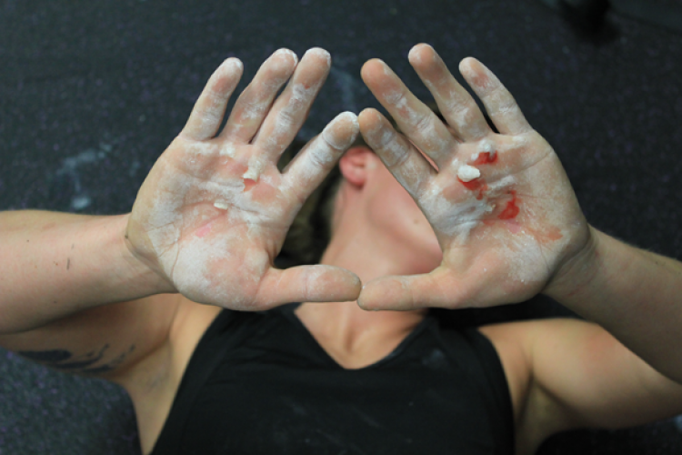

Hunched over with hands on knees, I gasped for air as beads of sweat dripped from my face, soaking the floor below me. Completing three cycles of running, shoulder press, and pull-ups it had taken eight minutes and twenty-three seconds to make my legs feel like rubber, and my arms feel like fire. As I sat down to catch my breath on the YMCA floor I felt several eyes on me, this was not your average workout.
I must confess that before I began my two-week journey at CrossFit515 I was compelled to complete a few CrossFit type workouts on my own. Whether it was to see how I stacked up against the competition, or merely to prove to myself that I had the stamina and mental capacity to finish a workout I am uncertain, but one thing I know: those first workouts crushed me. And that may be an understatement. Feeling slightly sick one morning I decided to overrule my good judgment and do a CrossFit workout anyway, shortly after I finished I tasted my breakfast for the second time. Every workout was sure to leave me with rubbery legs that could barely support my body. While I completed the routines with intensity nothing could prepare me for my first WOD at CrossFit515.
I walked into the gym on a beautiful Tuesday evening as the sun began to sink lower in the sky. Already having run sprints at tennis my shirt clung against my damp, sweaty skin. Arriving early, I was the first to show up to the five forty-five class, and I talked with Bobby and Jaime about my excitement for finally having the chance to participate. The WOD board displayed four separate workouts; today was a makeup/challenge/skill day - essentially a free gym day that can be used for making up or redoing a previous workout that week, or working on a certain CrossFit skill. I asked Bobby what he would recommend for my first workout and he pointed to Helen, the same workout that he had described in our interview as having the closest correlation to incorporating the numerous pieces of CrossFit. He also told me it was one of his favorite workouts, I should have realized that it would be my worst enemy.
To this day I believe Helen should be spelled Hell’en due to the physical agony it brings upon its’ victims. Helen consists of three rounds each containing a quarter mile run, twenty-one kettlebell swings (fifty-five pounds), and twelve pull-ups all in a brutal race against the clock. I found out that the race for an elite CrossFitter lasts approximately seven minutes. Considering myself to be in good shape I used the prescribed weights, including pull-ups without the help of an assistance band. In the seconds before I took off running around the strip mall containing CrossFit515 I remember hoping to keep my time under ten minutes, Helen was quite a bit more then ten minutes away from humbling me.
Myself and one other CrossFitter set off running counterclockwise around the strip mall - approximately ¼ mile. As I ran I concentrated on taking deep breaths and long strides, by the time I had circled the strip mall and reached the back entrance I was well ahead of the other member. Quickly glancing at the clock the time approached two minutes. Wasting no time I began on the kettlebell swings. Finding them easy on my first round through it gave me a chance to recollect myself and catch my breath, but as I swung the bell directly overhead I white-knuckled the handle for fear of dropping the dense weight. Twenty-one swings later with only one break to regain my grip I walked towards the network of twisted metal pull-up bars. Finding a sudden surge of strength twelve pull-ups came easily to me.
Hitting the ground after completing my last pull-up I took off running. I smirked looking back at the other member who was just beginning his pull-ups; I’m a natural, I thought to myself. But halfway through the run my legs began to burn with lactic acid, I pushed on solacing myself with the thought of catching my breath during the kettlebell swings. As I began the kettlebell swings, my shoulders, already tired from the pull-ups took on a sort of numbness as if they were refusing to do any more. With the encouragement of my back and legs twenty-one swings were finished. I let the kettlebell crash to the ground in a minefield of my own sweat drops. The pull-ups were gruesome. Shoulders numb, and not having developed the “kipping motion” that allows CrossFitters to complete stunning amounts of repetitions I kicked and wiggled for every inch. Taking several breaks and breathing deep to calm my heaving chest I began the last round.
My pace slowed to a crawling jog as I began the last quarter mile. My body told me to walk, but I knew that was not an option. I repeatedly gave myself encouragement, “one foot in front of the other,” I thought. Trotting into the back of CrossFit I approached the kettlebell. My forearms had never felt tighter as I gripped the handle, and it took all my strength to lift it from the ground. Swinging my first repetition overhead my grip loosened and the kettlebell wobbled in my hand. I focused all my energy in not letting the bell fly out of my hands, and used all my body to pop the weight overhead. As I walked to the pull-up bar I was not certain I could even support my own weight. The clock read twelve minutes; I aimed to complete the workout in thirteen.
I took the pull-ups in strides of three, then two, then single pull-ups using all my strength to pull my chin above the bar. Bobby stood to my right shouting encouragement. “Come on Mason! Lets Go! Six More!” With nine pull-ups down I swung my body and pulled-up with all my strength, but as I did I felt a searing pain shoot through my hands. I dropped off the bar and looked at my hands. The skin just below both my pinkie and ring finger was broken open and dead skin hung off both of my hands. Blood slowly trickled out of the wounds, and my hands shook as my heart raced. Bobby grimaced more than I did, “shoot,” he mumbled, “I really didn’t want that to happen.” He walked slowly to go get me tape, but I speed walked two paces in front of him. The time was still ticking and I needed to finish my workout. After promptly wrapping my hands in white athletic tape I jumped back up and regained my grip on the bar. It was agonizing just to hang from the bar, but one by one I continued on with the pull-ups. With my chin peaking over the bar for the twelfth time I fell onto the ground with shaky legs and sat atop a wooden box. I stared down at my hands as the white athletic tape slowly grew red spots where my hands revealed a deeper layer of flesh that normally remained hidden. I looked to my right; the other CrossFitter whom I had compared myself to after the first round was already stretching, some natural I am.
After stretching out my aching muscles I got a drink of water and talked to Bobby about the shape of my hands. He said it was best to cut off the dead skin, and wash them well, but the next piece of advice he gave I was not ready for. “I know it sounds terrible,” he explained, “but run them under warm water and when you take them out pour salt over the wounds. It will make them heal about twice as fast.” I laughed a little at the thought of the self-inflicted torture, but being a tennis player I needed my hands to recover as quickly as possible. I told him I would and my last words to him when I walked out the door were, “see you tomorrow.” I got the impression that he was unsure whether I would be back tomorrow, or ever, but there was not a doubt in my mind.
The drive home was a struggle with my stinging hands, and every time they came into contact with the steering wheel an electrifying jolt of pain travelled through my arms. Walking into my empty house I headed for the bathroom to perform what seemed like a barbaric sacrifice. Cutting off the dead skin, and sticking my hands into warm water was painful enough. My face contorted and every muscle and my body locked up. As I poured salt onto the open wounds in my left hand I felt nothing. “This isn’t so bad I thought,” but then, just like the beginning of the timed CrossFit workout, my body counted 3, 2, 1 and it hit me. I yelled with pain as the salt stung my hands, and tried to count to five to calm myself. I was unable to tolerate the anguish; sticking my left hand into the warm water brought on even more agony followed by intense relief. I let out a sigh and held up my hand to examine it in the mirror. It shook uncontrollably, and I could feel my heart pumping rapidly. Knowing the pain I was in for it took me a minute to pour salt on my right hand, but when I mustered up the courage I decided to pour salt on both hands. For some reason I inferred that more salt could only mean more healing - I retain the notion that I was delusional from the pain at the time. Salting both hands I let out a scream that could only be paralleled by one of Darren Lynn Bousman’s Saw horror Films (IMDB, n.d.). As the salt infested my bloodied hands I thought, “This is CrossFit.”
After my first workout I began to feel the vortex of CrossFit sucking me in. Over the next two weeks on the days that I attended class I found myself having more energy, eating healthier, and being in a better mood overall. As I write this I am slightly tired, sitting on my coach in sweats, eating a chocolate covered macadamia nut and caramel treat; Needless to say I did not go to class today. With a few days of participation underway I began logging onto CrossFit515.com with excitement to see the WOD that was in store for tomorrow. The progress I saw in my workouts grew daily and soon, I found myself in a world of CrossFit that seemed impossible to explain yet highly addictive.
While my infatuation focused purely on the workouts and physical gains of the program I discovered that other CrossFitters often glean more from the program - it is possible I simply have not participated long enough. Bobby said, “…For a lot of people it really drastically changes their life. The workouts we do are completely based off how hard you push yourself, so it’s all relative.” I related it to myself like this: I would rather take on another ethnography then relive my first experience with the workout Hell’en.

Rhabdo The Clown, Pukie, and The CrossFit Family
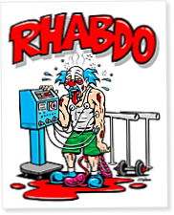

On December 22, 2005 the Physical Culture of The New York Times ran an article about Brian Anderson a Tacoma, Washington resident that left the gym with weary muscles and excruciating back pain after his first CrossFit workout. Not having worked out regularly in two years the pain forced Anderson to lie down in his driveway when he returned home. Later that night he checked in to the emergency room and was diagnosed with rhabdomyolysis, a condition in which muscle fibers break down into the bloodstream poisoning the kidneys. In fact, a common CrossFit mascot is a clown with kidneys and blood spilling out onto the floor with RHABDO in red across the top. (New York Times, Cooperman, 2005).
Six days later Brian Anderson was released from intensive care, and six months later he was back in the same CrossFit gym where he had suffered a close encounter with death. While experts weigh the risks of CrossFit with the health benefits in a balanced matter, other fitness aficionados attack the community from all angles.
CrossFitters seem to be the first group for taking criticism on training too intensely. In addition to Rhabdo the Clown many affiliate gyms keep track of ‘pukies’ or vomiting brought on from the intensity of a workout - like my experience in the YMCA bathroom, see Appendix A. While health is one issue raising eyebrows CrossFit bashers are quicker to jump on the actual exercises.
A huge complaint of those opposing the ideals of CrossFit is the form, or in their mind the lack thereof. Bobby Noyce says, “Everything we do is full body. There’s going to be no isolation, no machines, no pulleys…nothing like that.” In short, traditional bench pressing and bicep curls are rare to find - although one WOD I participated in did involve body-weight bench sets - compared to jump roping and back squats. With each workout being a race against the clock these full body movements are geared with speed in mind. Kipping pull-ups are a prime example of the criticism CrossFitters take on, and appear in many workouts. Kipping pull-ups have one objective: for the participant to get their chin above the bar as fast as possible. Forget traditional pull-ups, when CrossFitters get on the bar they use their body weight in a swinging motion to launch themselves upward and complete stunning amounts of repetitions - see Appendix B. Any grip is acceptable, and using your momentum while still being in control becomes an art form. The variation of pull-ups leads many shaking their heads and grumbling about the pull-ups being, “too easy.” What many people fail to take note of is that on rare occasion CrossFit WOD’s contain strict pull-ups, what the rest of the fitness community is accustomed to. While it is true that when a CrossFitter has mastered the form of Kipping pull-ups they can do many more repetitions than regular pull-ups the form is far from easy to learn. The first time I tried to kip while I performed pull-ups I struggled against my body weight, and only made the pull-ups harder. While CrossFitters have a different idea of form it is still strictly regimented.
At the most elite level of CrossFit, the CrossFit games, form is observed in the closest way possible. For every CrossFit games participant is a judge to count each repetition as well as make sure that their form is correct in doing so. Whether it is making sure a participant’s head touches the ground on a handstand push-up - See Appendix C - or that their hips drop below their knees on an overhead squat the judges are present in each workout (Bobby Noyce, Personal Communication, March 9, 2011).
While most of the people searching for flaws in the CrossFit system have made their minds up with little to no information, CrossFitters tend to have just as concrete of ideas. Diehard CrossFitters rarely train elsewhere, and are accused of being arrogant about the effectiveness and quality of their training. Throughout my time at CrossFit515 I observed only one conversation that is relevant to the accusation of arrogance. While Bobby and another member were talking about the P90X program, a ninety day video led workout that focused on body weight exercises, it was mentioned that while it is a good program it’s not much compared to what is done at CrossFit515. Shortly after Bobby commented, “I don’t know though, those guys on the video yell pretty loud,” in a joking manner. While they talked about the program in respected tones, it was clear they felt there was no comparison between it and a CrossFit WOD.
The lack of knowledge about CrossFit, and CrossFitters love of the training methods leads to verbal disputes that often turn ugly. With CrossFitters religiously attending classes at their gym they do not often meet face to face with those that oppose their fitness regiments; instead these verbal spars take place where both groups are connected at the click of a mouse, the World Wide Web. A CrossFit Games movie trailer uploaded to YouTube has received over one-hundred and forty thousand views, with one-hundred and sixty-seven of those viewers taking the time to leave their personal opinions in the form of a comment. The majority of comments are heavily opinionated which undoubtedly stems from the trailer itself. The trailer displays some big generalities that rise anger in those that disagree with the message being conveyed. Several people in the trailer describe the CrossFit Games winner as the, “fittest person on earth,” and one individual goes as far as insulting the Olympics. While talking about the safety of CrossFit and risks of hospitalizations a woman asks, “well what do they do in the Olympics?” to which he smirks and casually responds, “uhh, who cares?” From the opinionated promo came CrossFitters, avid athletes and even couch potatoes furiously typing away. The following are comments that the video elicited:
To everyone bashing CrossFit, obviously none of you have ever done a WOD. Go do a few WOD's like Fran, Elizabeth, Murphy, Tommy V....then come back and post....
Your all fat slobs that sit behind a computer that just hate the fact that you couldn't﻿ do what most CrossFitters do. (YouTube, 2010)

CrossFit is a way to be mediocre at all of the things you mentioned. Many of the criticisms here are based on that. Given a specific goal, there are more efficient ways to achieve that over a mediocre one size fits all program like CrossFit.

I puked twice during my first workout. Puking, along with my entire body feeling like I got hit by a freight train the next few days is enough to convince me that this is most definitely the BEST workout. There is a reason why MMA fighters use this for conditioning. We did CrossFit workouts in the military, and a few years later, most civilians I know still have never heard of it.

Giving a name﻿ to bad form doesn't make it cease to be bad form. The whole purpose of a pullup is to exercise the lats. Using your legs and momentum to take stress of the lats is just cheating so you can do more than would be possible with proper form.

What each comment lacked in English mechanics and grammar was made up in the raw, biased views that were displayed. Out of the hundred or so comments I read the only two that captured my respect were a simple question and answer between a CrossFitter and a non-CrossFitter. When one man asked, “It seems fun, but why are CrossFitters so arrogant?” (YouTube, 2011) to which another replied, “because everyone is always on our case about the way we train, so we stick together like a family.” The CrossFit family, it seems, is only strengthened by the hate they receive from outside.
With complaints concerning arrogance and technique rampant CrossFitters tend to take solace in the competition they have with one another. While the CrossFit community seems to have an answer to every complaint about their regiment as a whole they seem to be more preoccupied with their workouts than the opinions of others. As outsiders of the culture bash CrossFit technique and safety the tight knit community of CrossFit is brought closer one WOD at a time.

Strength For Life
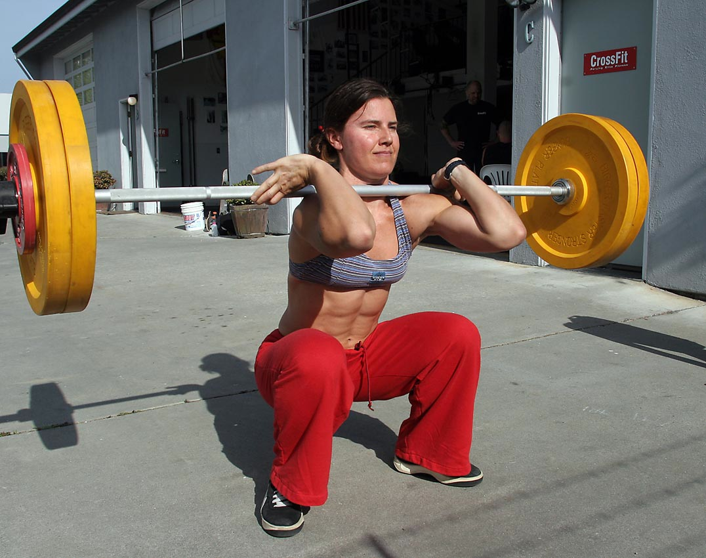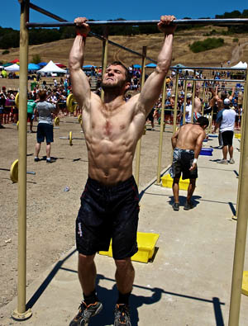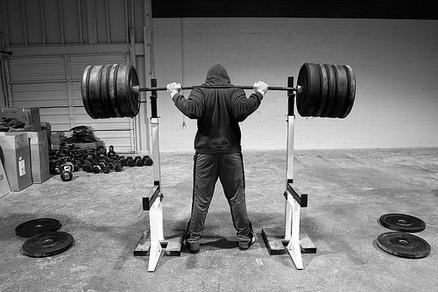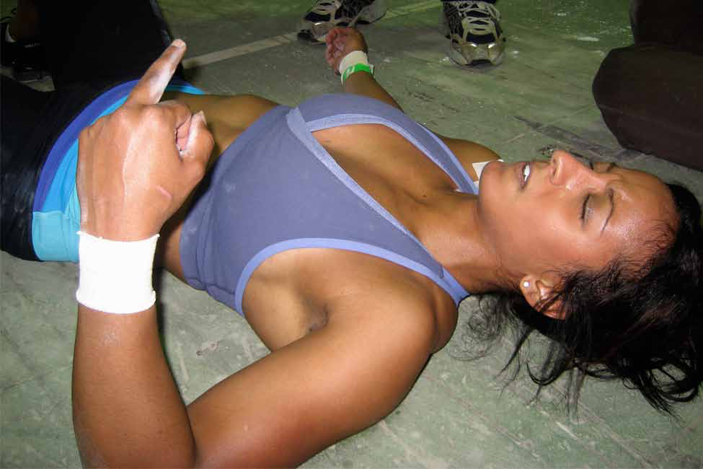

My first memories of CrossFit will always be the first video I saw advertising the CrossFit games. Lean bodies flying through grueling WOD’s juxtaposed with inspirational music that was sure to make any novice athlete want to join in on the competition. Each CrossFitter described the games in such an awe-inspiring manner that I was instantly hooked. At that point I assumed so much about the athletes and their training methods, without thinking about my own personal training and my definition of fitness. Little did I know spending time at CrossFit515 would challenge me to think in new ways.
When I observed and worked out at CrossFit not only was my physical stamina pushed, but my concept of fitness was redefined. I shed my ideas about what being fit was, and realized that as advertisers sensationalize body image over health the true components of being physically fit become lost. At CrossFit magic weight loss pills, testosterone boosting powders, and dangerous diets take a back seat to health. Never again will I say, “I’m in shape,” because I have learned that being fit is not an achievement, it is a journey. When I need a reminder all I need do is walk into CrossFit515 and watch the more talented members complete WOD’s at a fraction of my own time. The spirit of CrossFit will never die, because CrossFitters are constantly pushing themselves to the next level.
This constant desire for improvement is what sets apart a CrossFitter from your average weightlifter. CrossFitters do not look in the mirror to admire their physique they look on the WOD board to admire their times. As the manifestation of CrossFit creeps into ones life their habits change, for the better, to support their love of competition. Diet, sleep schedules, and relationships change as ones life begins to revolve around CrossFit.
In the short time that I have known Bobby I have gained confidence that his gym will succeed in every way it can. The love that Bobby has for CrossFit drives him to make each CrossFitter that steps into CrossFit515 a better athlete. Bobby represents what a CrossFitter is in every sense and gives his gym a model to look up to.
Still I think back to the cold, iron pull-up bar network that chews CrossFitters alive and harshly spits them out on the black, rubbery floor. This terrifying structure was a slap in the face as I ran full force into the world of CrossFit, a world that altered my perspective of fitness and goals, and quickly pulled me into its tight grasp. The pull-up network centered in CrossFit515 is similar to the journey that CrossFit presents. You head into the program with a direction of where you are going, but soon you are disoriented, twisted and turned backwards, and are on a completely different path then the one you set out for. Instead of a casual gym membership the participants find themselves addicted to the competitive nature of CrossFit. The pull-up bar is visited daily and until CrossFitters get their WOD fix they often feel incomplete. In the blink of an eye CrossFit becomes a lifestyle.
Diehard CrossFitters see the repercussions of their workouts in everyday life. Bobby Noyce said,
…people come in here and do things that they never thought they could do their entire lives, and push themselves harder then they ever thought they could push themselves…so, it kindove, basically makes everything else in life seem not as difficult… (Bobby Noyce, PERSONAL COMMUNICATION, March 9, 2011)
The lessons learned from CrossFit are born from the experience of giving it your all. Stepping up to an Olympic sized lifting bar with rubber weights totaling two-hundred on each side a CrossFitter pushes their body to its limit. And soon they find themselves giving their all to every aspect of life. At work they find themselves motivated and task driven. With their family they are both caring and supporting. No task seems impossible, and previous challenges become successes. In the buzzing gym of CrossFit515 CrossFitters continue to work on their fitness, giving them the strength necessary for life.

References
Cooperman, S. (2005, December 22). Getting fit even if it kills you. New York Times, Retrieved from http://www.nytimes.com/2005/12/22/fashion/thursdaystyles/22Fitness.html?_r=2
CrossFit. (2011, April 17). Retrieved from http://en.wikipedia.org/wiki/CrossFit
CrossFit movie working trailer "every second counts". (2005). [Web]. Retrieved from http://www.elementCrossFit.com/index.php/component/content/article/38-general/59-history-CrossFit-com
Ginger, Initials. (Photographer). (2010). Retrieved from http://landstuhlCrossFit.com/2010/06/21/workout-22-jun-2010/
The 300 workout. (n.d.). Retrieved from http://www.menshealth.com/fitness/muscle-building-11
Thiel, J. (2010). How to succeed as a CrossFit affiliate. Retrieved from http://journal.CrossFit.com/2010/01/how-to-succeed-as-a-CrossFit-affiliate.tpl
Retrieved from http://CrossFitimpulse.com/preparing-for-a-CrossFit-competition
Retrieved from http://CrossFittoriibeach.blogspot.com/
(2011). [Web]. Available from http://www.geauxCrossFit.com/index.php/P7/

Appendix A

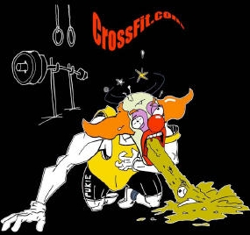

Pukie the Clown

Appendix B

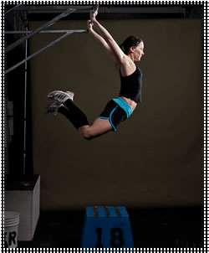

A still image of a Kipping pull-up

Appendix C

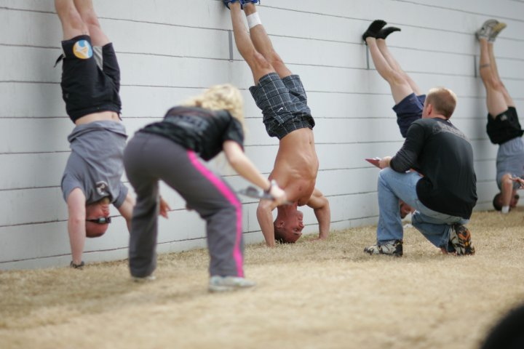

Judges monitor form during a CrossFit
competition

